**Daily Scrum or Standup Meeting**

Team name: ________Group 2_________________

Scrum Master: ______Emily_________________

Date:___________10/20____________________

| **Team Member** | **What did you do since the last scrum?** | **What do you plan to do before the next scrum?** | **What obstacles do you have?** |
| --- | --- | --- | --- |
| Emily | Finalized sprint planning documentation, configured Jira board | Get a manager to update the price markup | I have to wait on a menu model first |
| Karl Poulson | Created manager dashboard | Create customize drink dashboard | Creating the forum plus css styling |
| Maris Hurst | Planned when I can work on this | Extend/refactor user model | no time |
| Andre Nguyen | Started to implement the menu item model | Try to wrap up the menu item model | Wrapping up other classes |
|  |  |  |  |

# Burndown

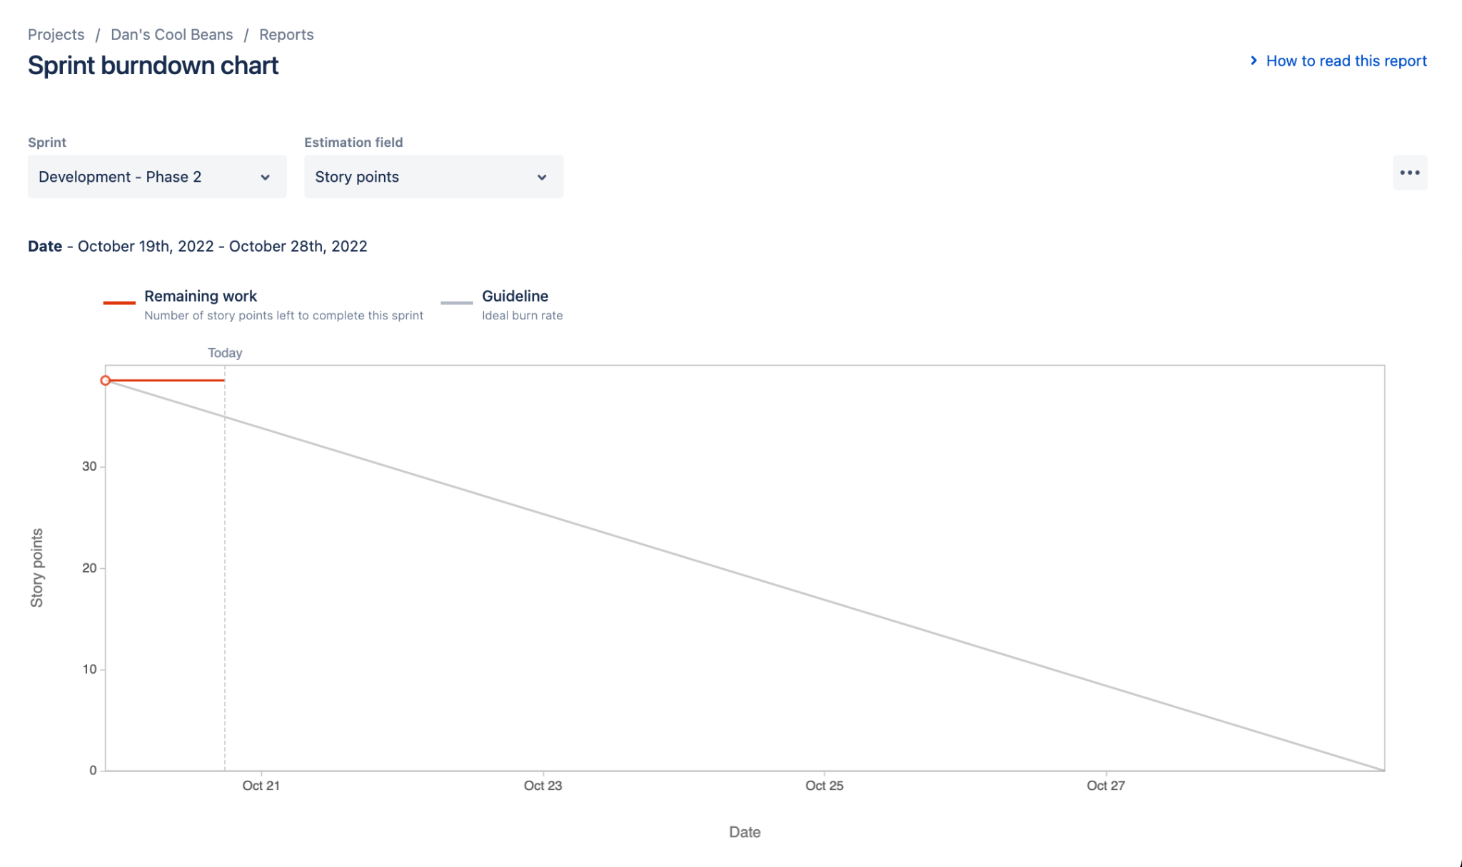

# Screenshot of you project board

